

Sample Approval Form

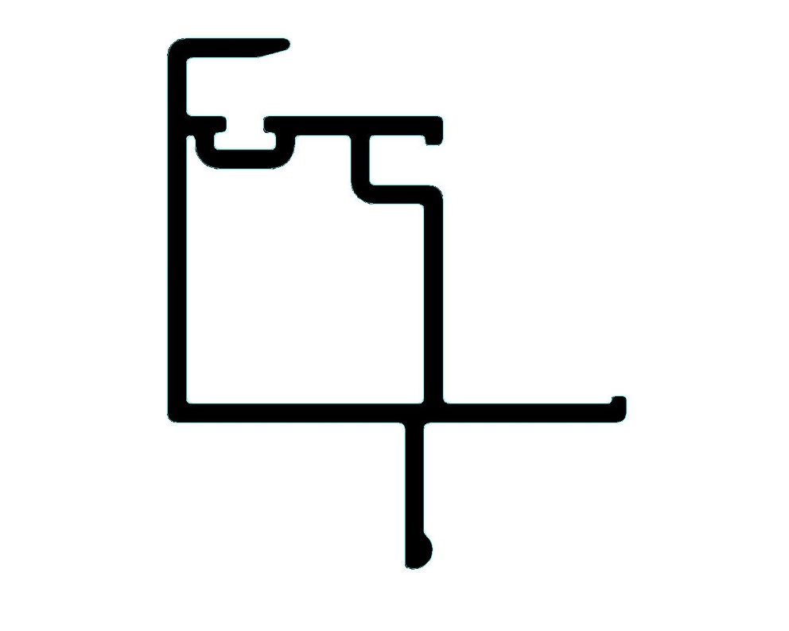
Customer: Solar Industries
Attention: Carl Sheldon
CSR: Mai Truong

Die #: 15003
Description: Sash Interlock

Rigid Colour: WH-136
Flex Colour: N/A
Capstock Colour: N/A

- Approved
- Approved with Comments
- Reject (Please Comment)
- Re-sample (Please Comment)

Comments: _____________________________________________________________________________________
______________________________________________________________________________________
______________________________________________________________________________________
______________________________________________________________________________________
______________________________________________________________________________________
______________________________________________________________________________________

Customer Signature: Vision Profile :

Customer Name: _________________________ QC Manager: Tri Thai__________________
Position: _________________________ Plant Manager: Pino Consolmagno_________
Signature: _________________________ Date: August 31, 2017___________
Date: _________________________
Notes:
- Please sign this form and return to your Customer Service Representative. Keep a copy for your records.
- Please sign a one foot sample. Return one (1) to your Customer Service Rep. and retain one (1) for your records.
- “Approved” indicated that the samples meet all the specifications required for your proper manufacturing and fabrication purposes. An “Approved” Status indicates Customer consent for Vision Profile to anodize and harden the tooling for production.
- “Approved with Comments” indicates that the sample does not meet all the specifications required for your proper manufacturing purposes, however, the issues can be addressed before production begins, without the need for re-sampling. Please consult with Vision Profile for any technical support you may need to address these issues.
- If samples are rejected, please explain in the comments section.
- If re-sampling is required, please explain in the comments section.

